BCB-Berkeley
User Manual
How to use the BCB-Berkeley inventory system
Web address: https://bcb-berkeley-inventory.web.app
For: Everyone who uses the inventory: store staff, managers and administrators
Version: 1.0 · October 2026

Contents

Right-click the table and choose Update Field if page numbers look out of date.

1. Welcome
This inventory system keeps track of everything in the store: what you have, what comes in, what goes out, and what is running low. It works in any web browser, on a computer, tablet or phone, and everyone sees the same numbers at the same time.

What you can do with it
- Receive stock when deliveries arrive (Stock In).
- Issue stock to the bar, kitchen or other areas (Stock Out).
- Correct counts when items are damaged, lost or counted differently (Stock Adjustments).
- See everything at a glance on the Dashboard.
- Look back at every movement in Movement History.
- Download reports to Excel, CSV or PDF.

Words used in this manual
Word | What it means
Item | Anything you keep in stock, for example “Arabica (Whole Beans)” or “8oz Kraft Cup”.
SKU / Item code | The short code that identifies an item, for example CB-001. Every item has its own.
UoM (unit of measure) | How an item is counted: pack, pcs, bottle, carton, can and so on.
On hand | How many of an item you have right now.
Minimum stock | The level at which an item should be re-ordered. At or below it, the item shows as Low Stock.
Stock In | Recording items that arrived (a delivery or purchase).
Stock Out | Recording items taken out of storage for use.
Adjustment | A correction to the on-hand quantity, with a reason.
Reversal | Cancelling a transaction that was saved by mistake. The original stays on record.
Transaction number | The reference number every saved movement gets, for example SO-20261013-6G6N.

2. Getting started

Signing in
- Open https://bcb-berkeley-inventory.web.app in your browser. Bookmark it, or on a phone choose “Add to Home Screen”.
- Click Sign in with Google.
- Choose the Google account (Gmail) that your administrator added for you.
- The Dashboard opens.
Note: If you see “No access yet”, your Google account is not on the access list. The page shows the email you used. Ask an administrator to add exactly that email under User Access, or click Use a different account and pick the right one.

Signing out
On a computer, click Sign out at the bottom of the left menu. On a phone, tap Sign out in the top bar. The button asks you to tap a second time so you don’t sign out by accident. Always sign out on shared computers.

What you can do depends on your role
Every person has one of three roles. Your role is shown under your name at the bottom of the left menu.
Role | Typically for | Can do
Administrator | Store manager, owner | Everything: items, stock in/out, approve adjustments, reverse mistakes, manage people, settings, backups.
Inventory Staff | Stock keepers, baristas, kitchen staff | Add and edit items, record Stock In and Stock Out, request adjustments.
Viewer / Manager | Area managers, accounting | Look at the Dashboard, items, history and reports, and download reports. Cannot change anything.

If a page says “Not available”, your role does not include that function.

3. Finding your way around
The menu on the left takes you to every part of the system. On a phone, tap the ☰ button at the top left to open it.
Menu | Use it to
Dashboard | See the overall picture: totals, alerts and charts.
Inventory Items | Find items, see their details, add or edit items.
Stock In | Record deliveries and items received.
Stock Out | Record items issued for use.
Stock Adjustments | Correct quantities, and approve corrections (administrators).
Movement History | See every movement ever recorded.
Reports | Run and download the seven reports.
User Access | See roles; administrators add or remove people.
Settings | Administrators only: options, lists, backups.

Look and feel
- Theme: at the bottom of the left menu, choose Light, Dark, or Auto (follows your device). Dark is easier on the eyes at night.
- Density: choose Comfortable (larger, easier to read) or Compact (fits more rows on the screen).
- These choices are remembered on your own device only.

On a phone
The system works on phones. Large Stock In and Stock Out buttons sit at the bottom of the screen so you can record movements quickly while standing in the storeroom.
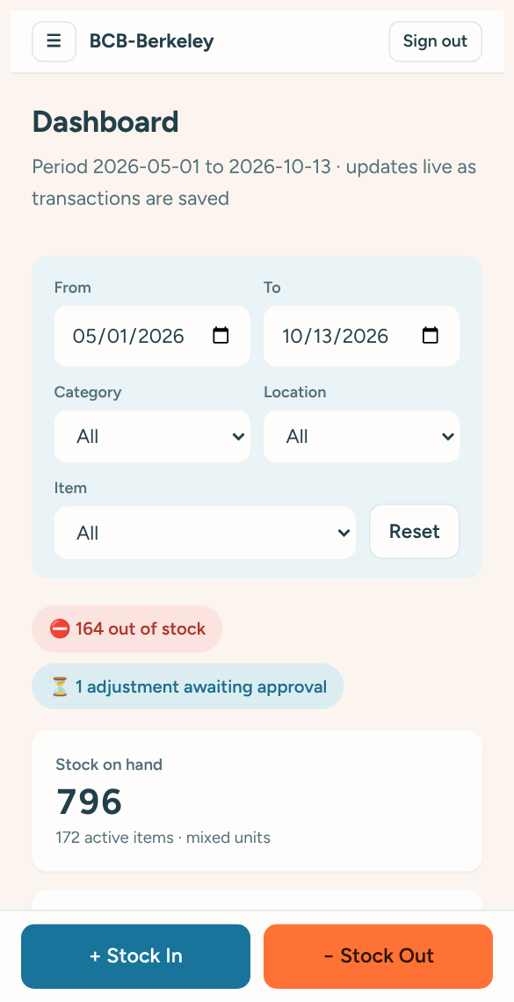
The Dashboard on a phone, with the Stock In / Stock Out buttons at the bottom

Messages you will see
- Green message (bottom right): something was saved successfully.
- Red text under a field: something needs fixing before it can be saved. It tells you what to change.
- “Reconnecting to the inventory…” (top of the screen): the internet dropped for a moment. The system reconnects by itself; anything you already saved is safe.

4. The Dashboard
The Dashboard is the home page. It updates by itself whenever anyone saves a transaction.
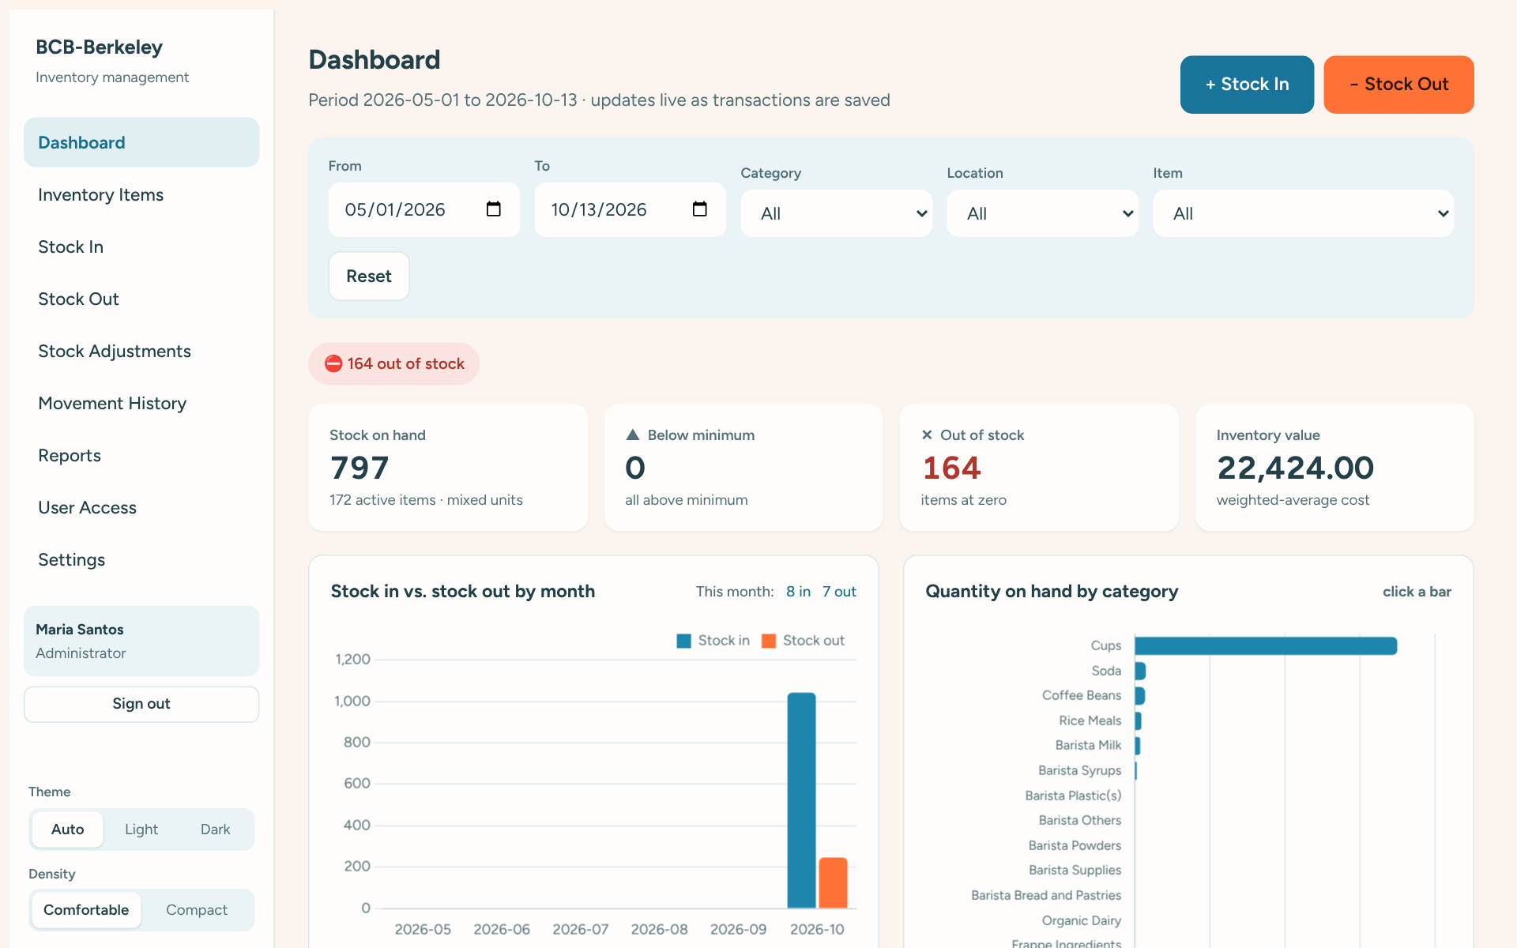
The Dashboard

Top of the page
- Stock In / Stock Out buttons for quick recording.
- Filters: choose dates, a category, a storage location or one item to narrow down everything on the page. Click Reset to go back to all.
- Alerts (coloured pills): items out of stock, items at or below minimum, adjustments waiting for approval, and unusual movements. Click an alert to see the items involved.

The four boxes
Box | Shows | Click it to
Stock on hand | Total quantity of all active items (all units added together). | Open the Current Stock report.
Below minimum | Items at or below their minimum stock level. | See those items.
Out of stock | Items with zero on hand. | See those items.
Inventory value | Total value of stock at average cost. | Open the Valuation report.

Charts and lists
- Stock in vs. stock out by month: blue bars for stock received, orange for stock issued. Click a bar to see those movements. The numbers for this month sit at the top right of the chart.
- Quantity on hand by category: which categories hold the most stock. Click a bar to see that category’s items.
- Top 10 most frequently issued: the items used most often in the selected period.
- Low-stock items to replenish, Recent transactions, and No movement in period (items nobody has touched).

5. Inventory Items

Finding an item
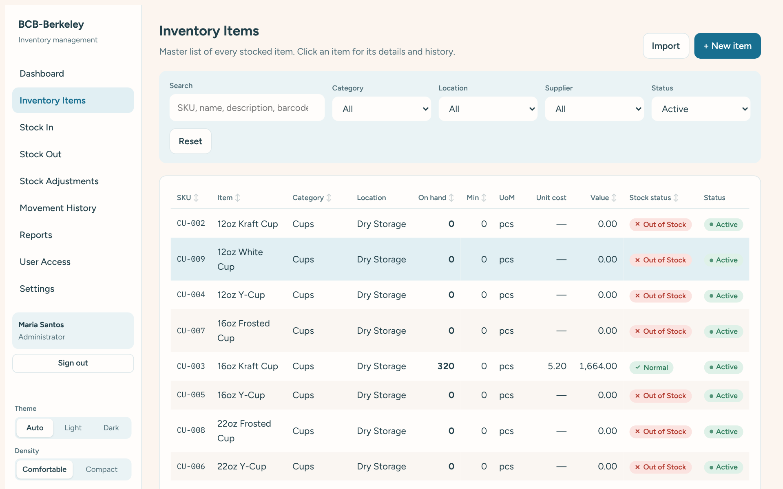
The Inventory Items list
- Type in Search to find items by code, name, description or barcode.
- Use Category, Location, Supplier and Status to narrow the list. Status can show only Active items, only items In stock (> 0), only Low Stock, only Out of Stock, and so on.
- Click a column heading (for example On hand) to sort by it. Click again to reverse.
- Click Reset to clear all filters.

Seeing an item’s details
Click any item to open its details on the right side of the screen.
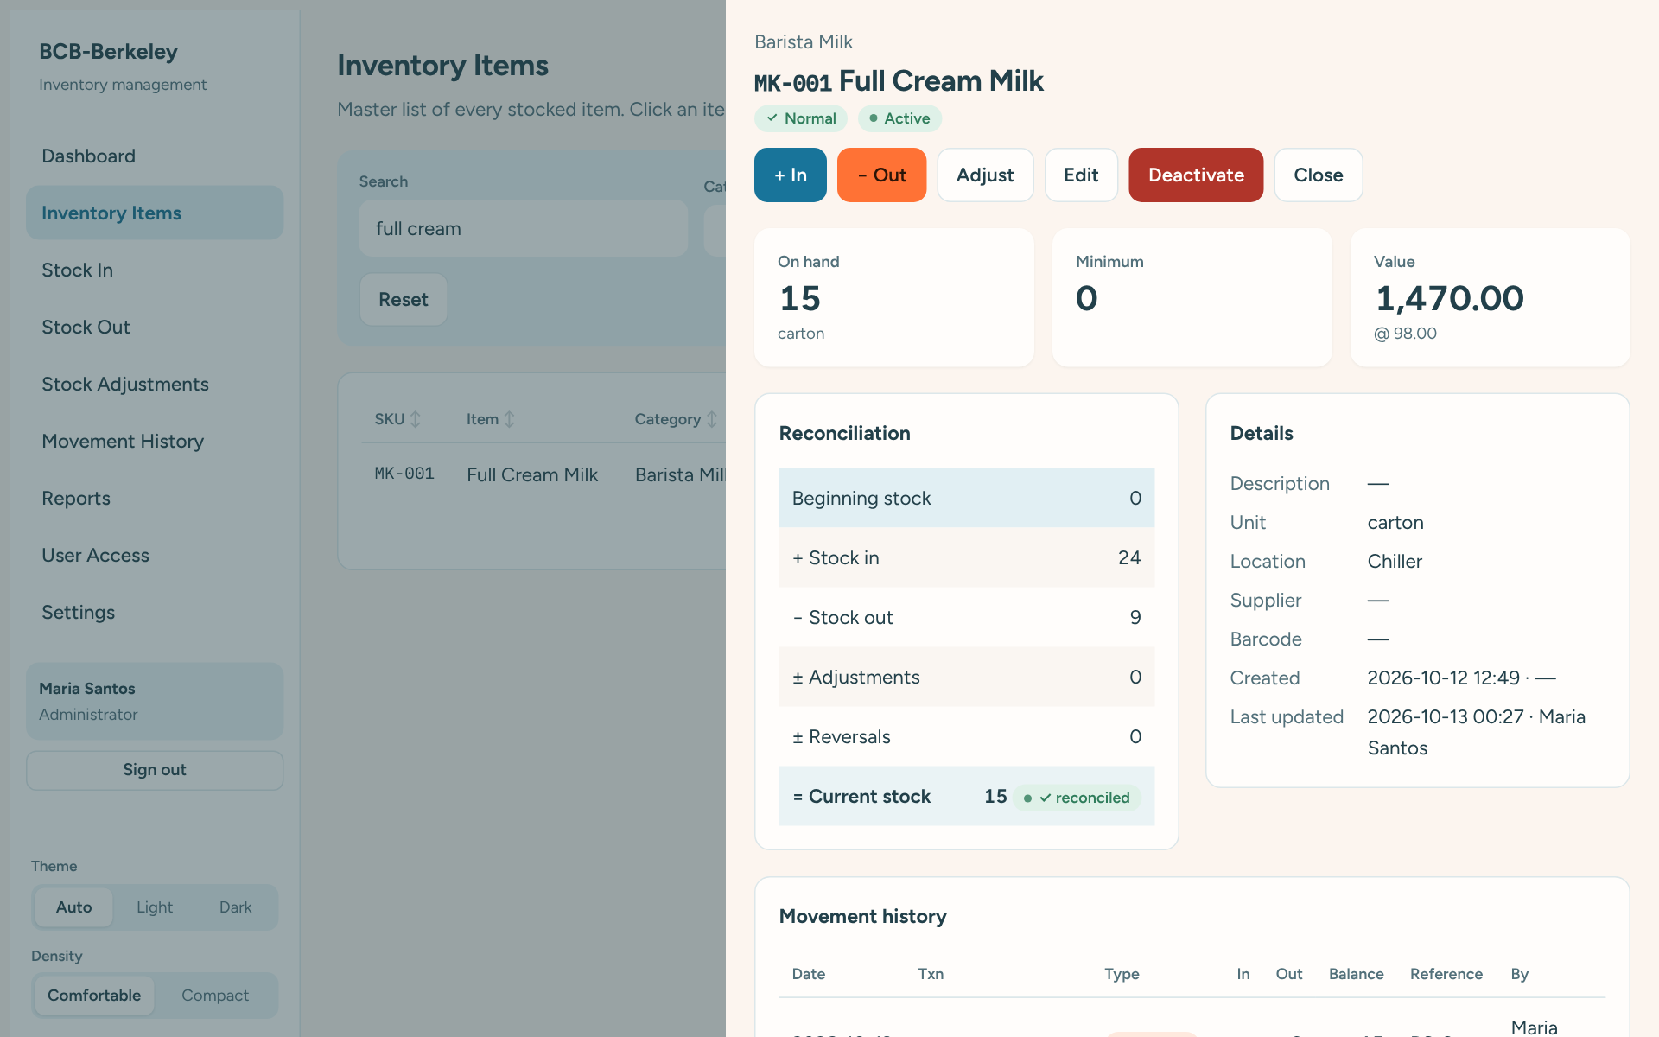
Item details: stock, reconciliation, details and movement history
- On hand, Minimum and Value at the top.
- Reconciliation shows how the current stock was reached: beginning stock, plus stock in, minus stock out, plus or minus adjustments. A green ✓ reconciled means the numbers agree with the history.
- Movement history lists every movement of this item, newest first. Click one to see its details.
- Buttons at the top let you record + In, − Out or Adjust for this item straight away.

Adding a new item
- Go to Inventory Items and click + New item.
- Fill in the Item name, Category and Unit of measurement (required, marked with *).
- Leave Item Code / SKU empty to have it created for you (for example CB-023), or type your own.
- Enter Beginning stock if you already have some on hand. It is recorded as the item’s opening balance.
- Optionally set Minimum stock level, Storage location, Supplier, Unit cost and Barcode.
- Click Create item.
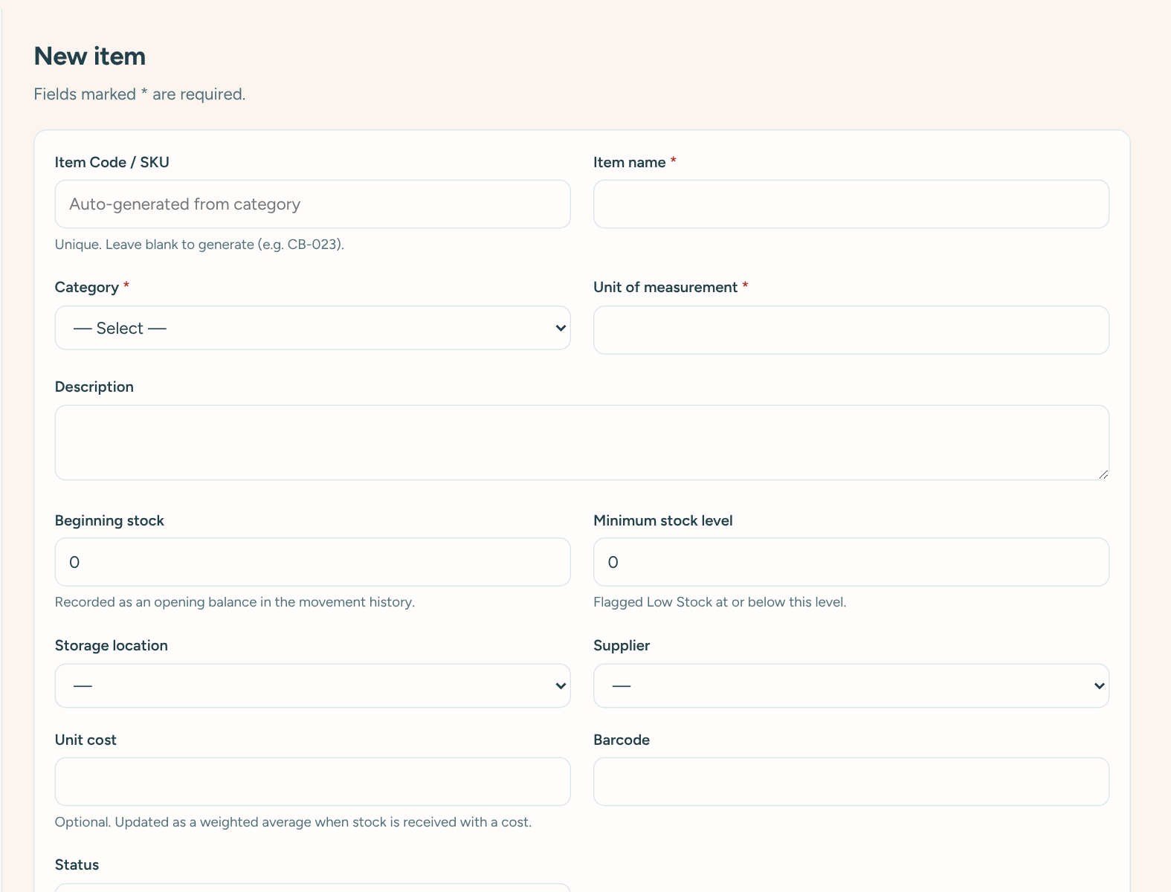
Adding a new item

Editing an item
Open the item and click Edit. You can change its name, category, unit, description, minimum level, location, supplier, cost and barcode. Click Save changes.
Note: You cannot type in a new stock quantity when editing. Quantities only change through Stock In, Stock Out or an Adjustment, so that every change is on record.

Deactivating an item (administrators)
If an item is no longer used, open it and click Deactivate. It disappears from the Stock In and Stock Out lists but its history is kept. Click Reactivate to bring it back.

Importing many items from Excel
- Go to Inventory Items and click Import.
- Click Download Excel template and fill it in: one row per item. Item Name, Category and UoM are required.
- Back on the Import page, choose your file and click Import.
- The page tells you how many items were created and lists any rows that could not be imported, with the reason.

6. Receiving stock (Stock In)
Use Stock In whenever items arrive: a delivery, a purchase or a transfer in.
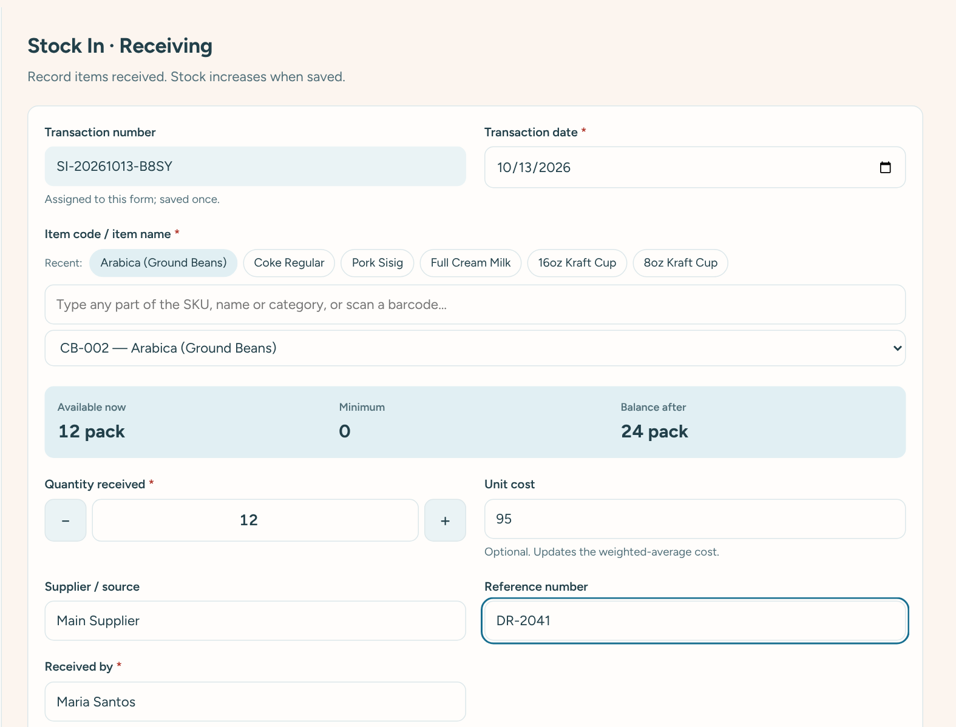
The Stock In form
- Click Stock In in the menu (or + Stock In on the Dashboard).
- Check the Transaction date. It is today unless you change it. It cannot be in the future.
- Find the item: type part of its name or code in the search box (for example “milk” or “cb-001”), then pick it from the list. You can also tap one of the Recent buttons for items you used lately.
- The coloured box shows Available now and what the Balance after will be.
- Enter the Quantity received. Use the − and + buttons or type the number.
- Optionally enter the Unit cost, Supplier / source and Reference number (delivery receipt or PO number).
- Check Received by (your name is filled in) and add Remarks if needed.
- Click Save stock in. A green message confirms it with its transaction number and the new balance.
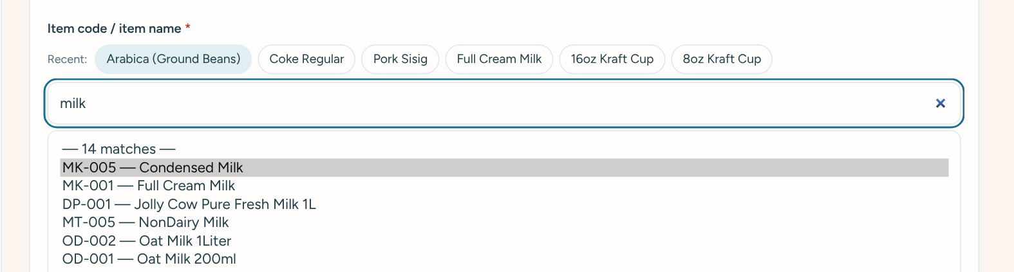
Searching: typing “milk” shows the matching items, best matches first
Tip: The search finds an item if what you type appears anywhere in its name, code or category. You can type several words in any order, for example “arab ground” finds Arabica (Ground Beans). Scanning or typing an exact item code or barcode selects the item straight away.

7. Issuing stock (Stock Out)
Use Stock Out whenever items are taken from storage for use: to the bar, kitchen, front counter and so on.
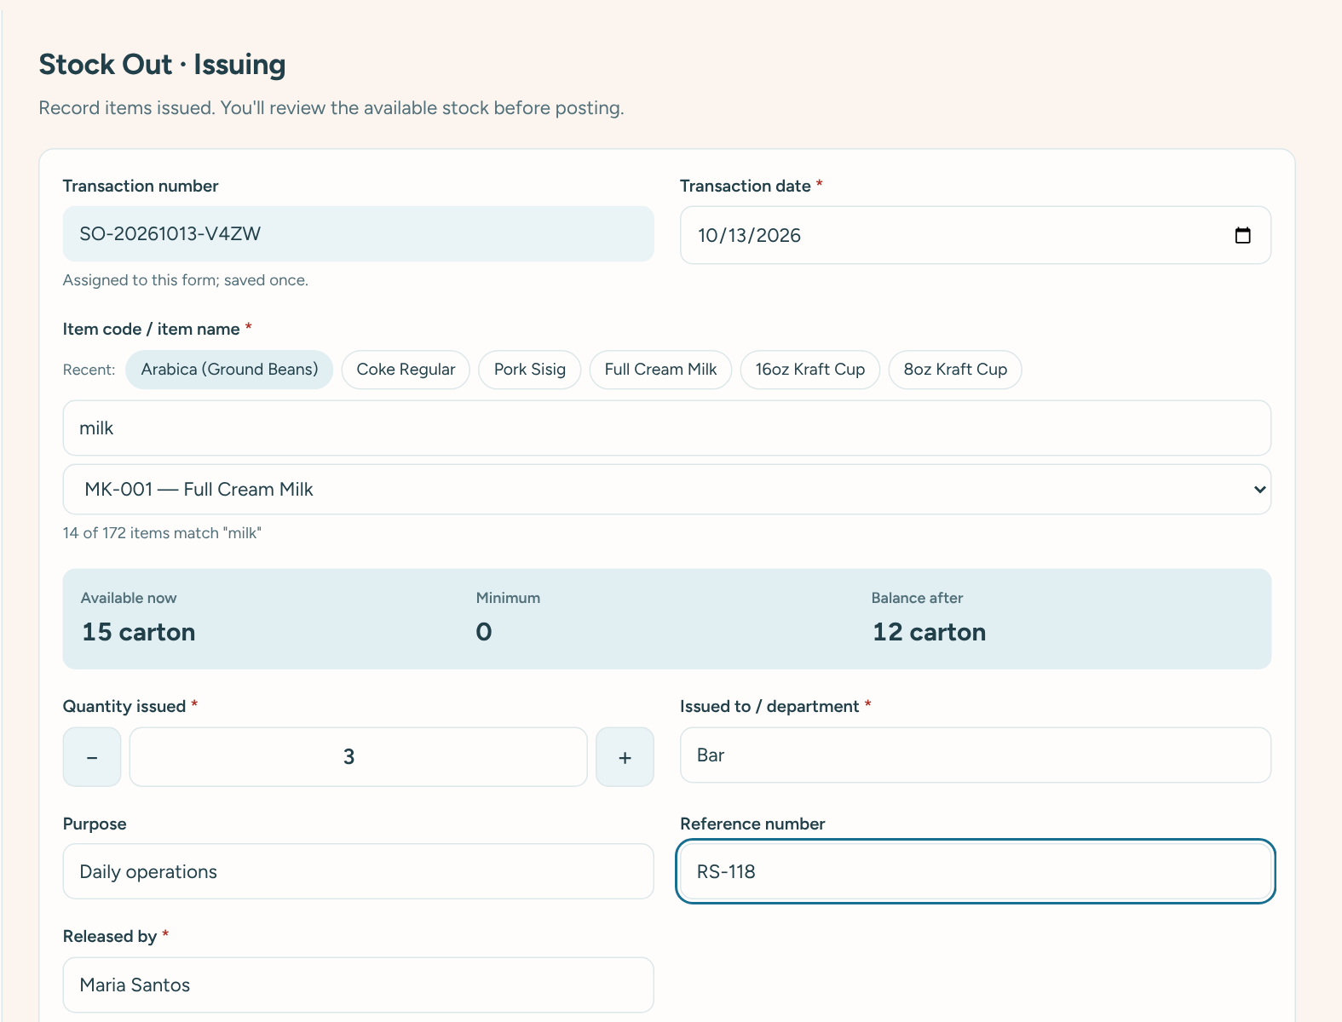
The Stock Out form
- Click Stock Out in the menu (or − Stock Out on the Dashboard).
- Find and pick the item, the same way as for Stock In.
- Enter the Quantity issued.
- Fill in Issued to / department (required, for example Bar or Kitchen) and, if useful, Purpose and Reference number.
- Check Released by and click Review stock out.
- A confirmation page shows what is available now, how many you are issuing, and the balance after. Check everything.
- Click Confirm & post to save, or Back to edit to change something.
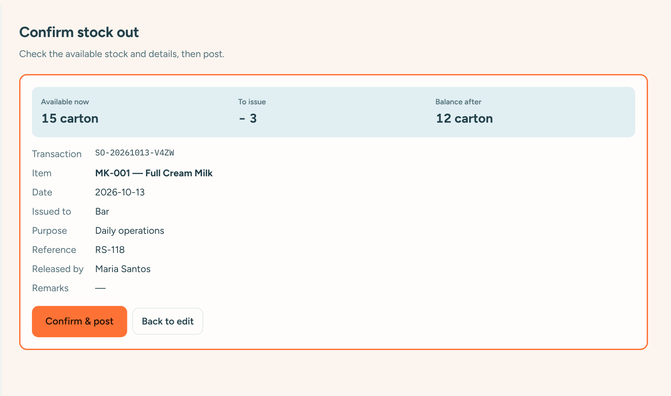
Checking a stock out before it is saved

When there isn’t enough stock
The system will not let you issue more than you have. You will see a red message under the quantity telling you how many are available.
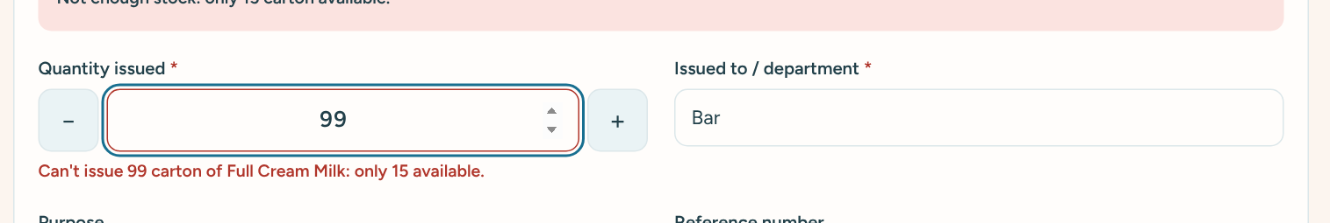
Trying to issue more than is available
Note: If someone else issues the same item at the same moment, the system re-checks the stock when you confirm. If there is no longer enough, it tells you and nothing is saved.

8. Stock adjustments
Use an adjustment when the real quantity on the shelf is different from what the system shows, for example after a physical count, or when items are damaged, lost or expired.

Requesting an adjustment
- Go to Stock Adjustments and click + New adjustment (or click Adjust on an item).
- Pick the item. The System quantity shows what the system thinks you have.
- Enter the Actual quantity: what is really there.
- Choose a Reason: Physical count, Damaged, Lost / missing, Expired / spoiled, Data-entry error, or Other.
- Add Remarks. They are required when the reason is Other, and always helpful.
- Click Submit for approval (staff) or Post adjustment (administrators).
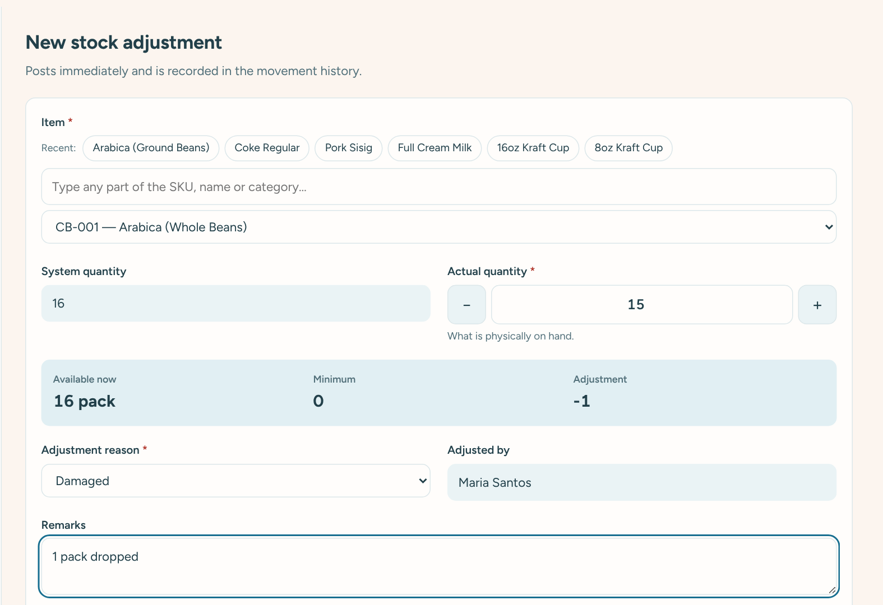
A new adjustment: the difference is calculated for you
Adjustments by Inventory Staff wait as Pending until an administrator approves them; stock does not change until then. Adjustments by administrators take effect immediately.

Approving or rejecting (administrators)
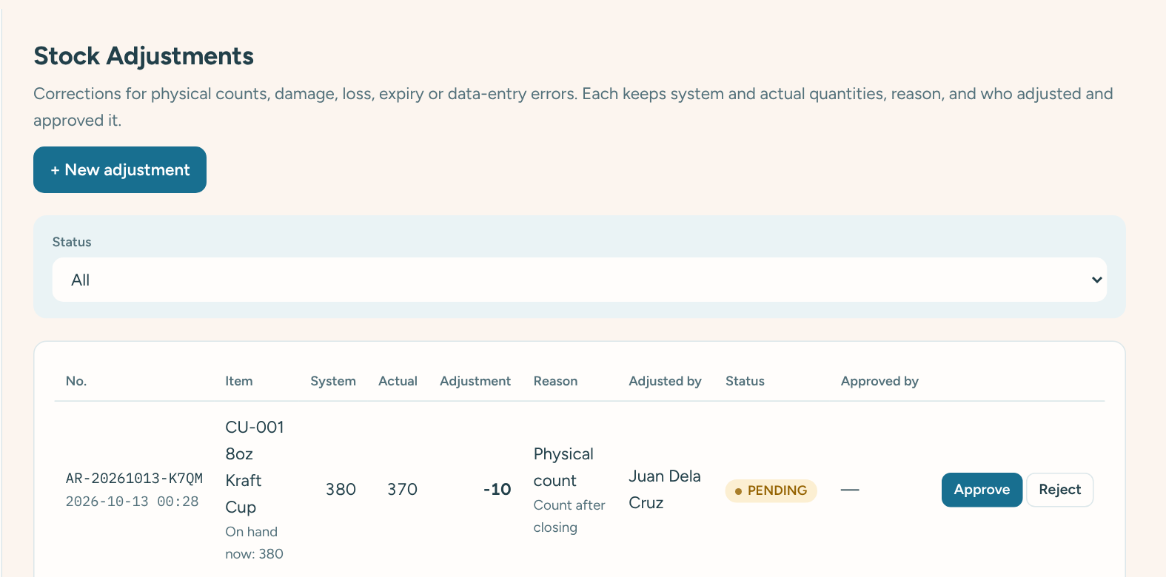
A pending adjustment with Approve and Reject buttons
- Pending adjustments are listed first, and the Dashboard shows an alert when any are waiting.
- Click Approve to apply it. The stock changes and it appears in Movement History.
- Click Reject, type a short reason, and confirm. The stock does not change.
- Every adjustment keeps the system quantity, actual quantity, reason, who asked and who approved.

9. Fixing a mistake
Saved transactions cannot be edited or deleted. This keeps a trustworthy record. If something was saved by mistake, an administrator reverses it:
- Find the transaction in Movement History (or in the item’s details) and click it.
- In the details panel, type the Reason for reversal, for example “Wrong item selected”.
- Click Reverse transaction.
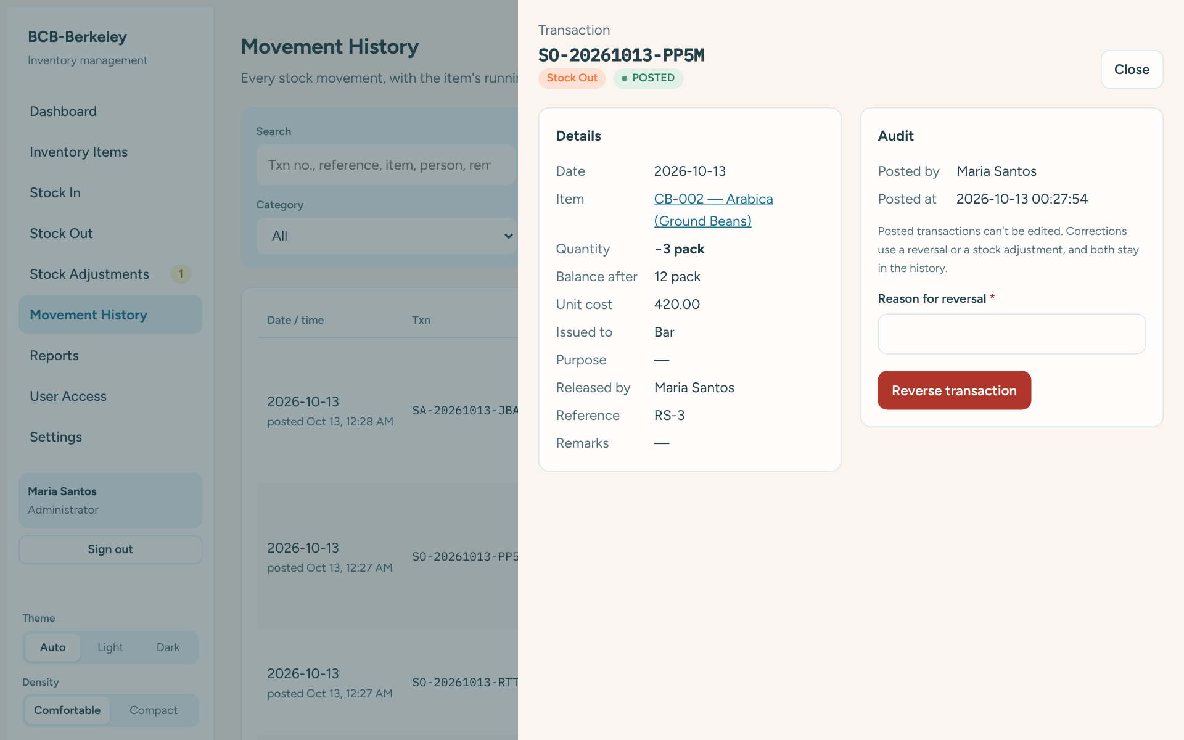
Transaction details, with the reversal box at the bottom (administrators)
The reversal puts the stock back as it was, and gets its own number (starting with RV). The original stays in the history, marked REVERSED, so anyone can see what happened and who corrected it.
Tip: Inventory Staff who notice a mistake should tell an administrator, or request an adjustment with the reason “Data-entry error”.

10. Movement History
Movement History lists every stock movement ever recorded, newest first: receipts, issues, adjustments, reversals and opening balances.
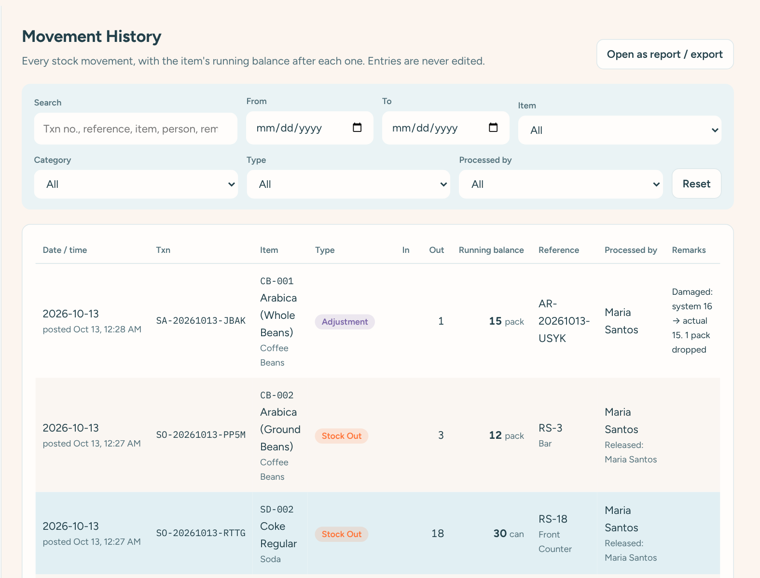
Movement History
- Each row shows the date, transaction number, item, type, quantity in or out, and the running balance of that item after the movement.
- Filter by date range, item, category, type, or who processed it. Use Search for reference numbers, names or remarks.
- Click any row to see all its details.
- Click Open as report / export to download the same list.
Type | Meaning | Number starts with
Opening balance | Beginning stock entered when an item was created | OB
Stock In | Items received | SI
Stock Out | Items issued | SO
Adjustment | Approved correction | SA
Reversal | Cancellation of a mistaken transaction | RV

11. Reports
Go to Reports and click the report you need.
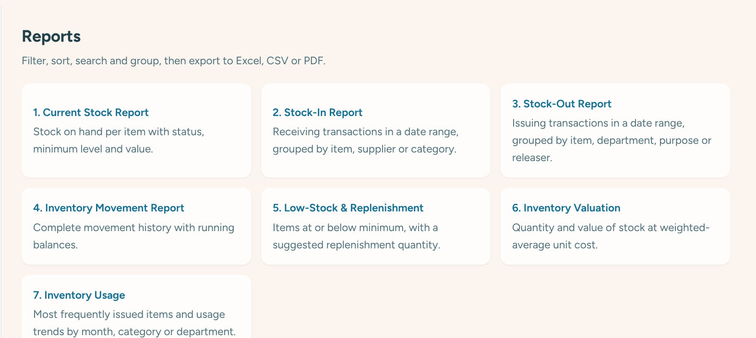
The seven reports
Report | Use it to
Current Stock | See what you have of every item, with status and value.
Stock-In | List deliveries in a date range, by item, supplier or category.
Stock-Out | List items issued in a date range, by item, department, purpose or person.
Inventory Movement | Get the full history with running balances, for checking or auditing.
Low-Stock & Replenishment | See what needs re-ordering and a suggested quantity to order.
Inventory Valuation | See the value of your stock by category.
Inventory Usage | See the most-used items and usage per month, category or department.

Using a report
- Set the filters at the top: dates, category, location, item and so on. The report updates straight away.
- Tick Only items with stock > 0 (on the stock, low-stock and valuation reports) to hide items you don’t have.
- Use Group by to show subtotals, for example by category or supplier.
- Click a column heading to sort.
- Click Excel, CSV or PDF to download. The file shows the date, who made it and the filters used.
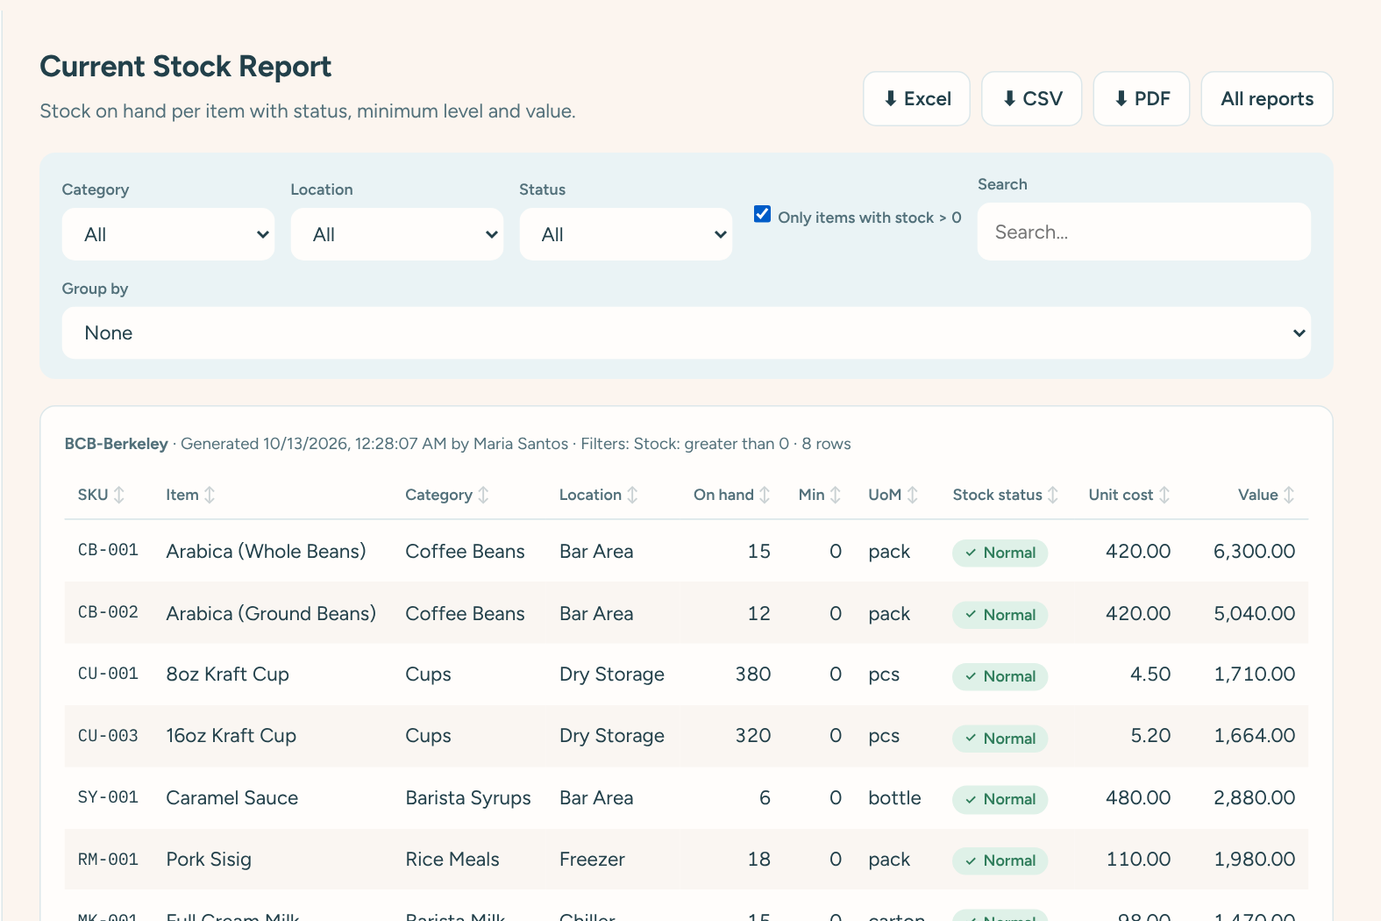
The Current Stock report, showing only items in stock
Tip: The Low-Stock report suggests how much to order so each item reaches twice its minimum level. An administrator can change the “twice” in Settings.

12. User Access (administrators)
Administrators decide who can sign in and what they can do.
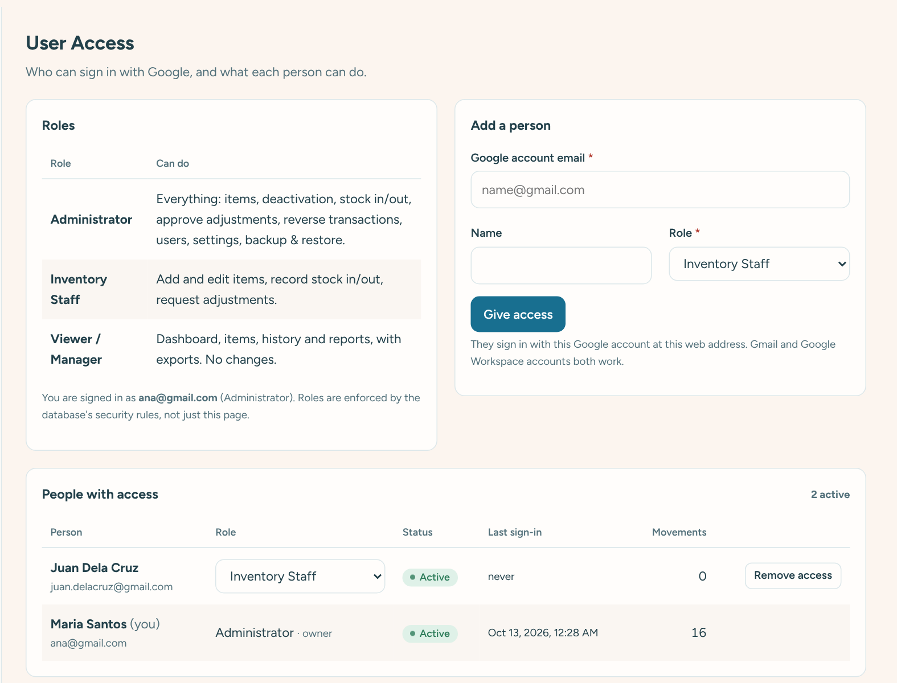
User Access: roles, adding a person, and the list of people

Adding a person
- Go to User Access.
- In Add a person, type their Google account email (their Gmail, or company Google account).
- Optionally type their Name. Their Google name is used automatically after they first sign in.
- Choose their Role and click Give access.
- Send them the web address. They sign in with that same Google account.

Changing a role or removing access
- In People with access, choose a new role from the drop-down next to their name. It takes effect the next time their page loads.
- Click Remove access to stop someone signing in, for example when they leave. Their past work stays in the history. Restore access lets them back in.
- You cannot change your own role, or the owner’s, so nobody can lock themselves out by accident.

Audit trail
At the bottom of User Access, administrators can click Load latest to see the last 90 days of important changes: items added or edited, approvals, reversals, user and settings changes, with who did them and when.

13. Settings (administrators)
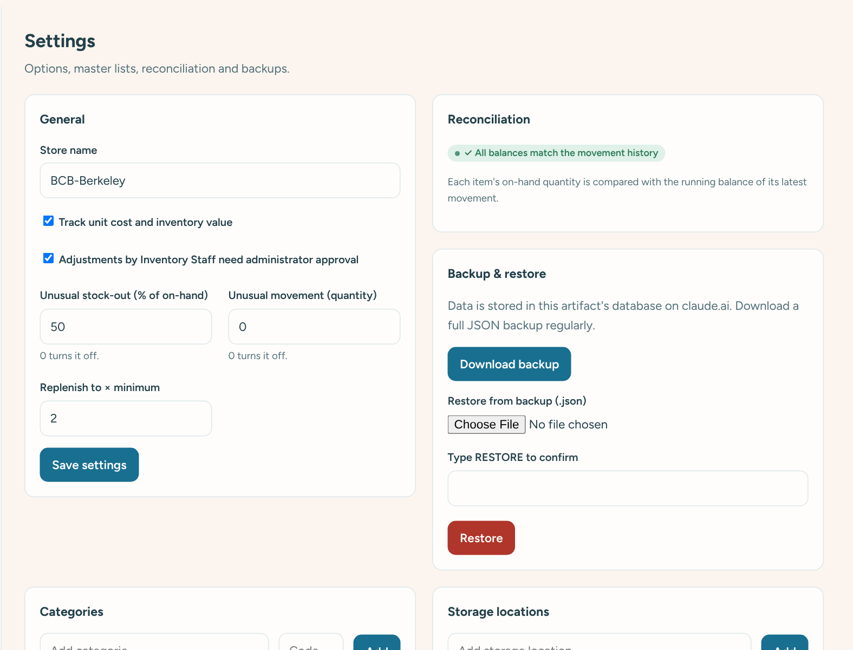
Settings

General
Setting | What it does
Store name | Shown at the top of the menu and on reports.
Track unit cost and inventory value | Turn costs and values on or off everywhere.
Adjustments by Inventory Staff need approval | When on, staff adjustments wait for an administrator.
Unusual stock-out (% of on-hand) | Flags any single stock out larger than this share of what was on hand. 0 turns it off.
Unusual movement (quantity) | Flags any single movement above this quantity. 0 turns it off.
Replenish to × minimum | Used by the Low-Stock report to suggest order quantities.

Lists
Add, rename or deactivate Categories (with their short code used for new item codes), Storage locations and Suppliers.

Reconciliation
Checks that every item’s on-hand quantity matches its movement history. It should always show ✓ All balances match. If not, it lists the items and offers to correct them.

Backup and restore
- Download backup saves a complete copy of the inventory to your computer. Do this regularly, for example every week, and keep the files somewhere safe.
- Restore replaces all current data with a backup file. Type RESTORE to confirm. Only do this if something has gone badly wrong.
Important: Restoring cannot be undone. Download a fresh backup first, so you can go back if needed.

Starting item list
When the inventory is empty, Settings shows a Load starting items button. It loads the 172 items from the October 2026 count sheet with zero stock.

14. Common questions
Question | Answer
I see “No access yet”. | Your Google account isn’t on the access list. Ask an administrator to add the exact email shown on the screen.
I can’t find an item in Stock In or Stock Out. | It may be inactive. Search for it in Inventory Items with Status set to All, and ask an administrator to reactivate it.
It says I can’t issue that many. | There isn’t enough on hand. If the shelf really has more, the stock count is wrong: record the missing Stock In, or request an adjustment.
I saved something wrong. | Ask an administrator to reverse it (section 9). Saved transactions can’t be edited.
A page says “Not available”. | Your role doesn’t include that function. Ask an administrator if you need it.
“Reconnecting to the inventory…” stays on screen. | Check your Wi-Fi or mobile data. If it stays for more than a minute, reload the page.
“You don’t have permission to make this change.” | Your role doesn’t allow that action, or your access was changed. Reload the page; ask an administrator if it continues.
The numbers look old. | Reload the page. Normally it updates by itself within seconds.
Can I use it on my phone? | Yes. Open the same web address and sign in. Add it to your home screen for one-tap access.

Good habits
- Record movements as they happen, not at the end of the day.
- Always fill in a Reference number for deliveries (delivery receipt or PO) and requisitions.
- Do a physical count regularly and record differences as adjustments with the reason “Physical count”.
- Administrators: download a backup every week.
- Sign out on shared computers.

